**Environmental stochasticity and resource heterogeneity may have driven the evolution of cooperation on Rapa Nui**

**Authors & affiliation**

**CM Lynch1, M Starkey2, CP Lipo3 , TL Hunt4**

**1School of Life Sciences, Arizona State University**

**2School of Computing, Informatics, and Design Systems Engineering, Arizona State University**

**3Anthropology Department, Binghamton University**

**4School of Anthropology and Honors College, University of Arizona**

**JASS:** [**https://www.jasss.org/admin/submit.html**](https://www.jasss.org/admin/submit.html)

**Example for paragraph numbers: https://www.jasss.org/11/2/3.html**

**Abstract**

Historians long believed that the island of Rapa Nui experienced a huge population crash, as it did not seem possible that the small number of inhabitants could have built and transported the hundreds of statues on the island. These historians then asserted that the population crash was caused by the islanders themselves by stripping the island of its resources. However, these ideas have not been supported. Instead, evidence shows that a stable society had persisted on the island for centuries despite the extreme ecological constraints imposed upon them. Indeed, ecological constraints can help explain how cooperative traditions may have been selected for from the beginning. One difference between Rapa Nui and other islands is that rainfall there is more difficult to predict. This unpredictability may have driven cooperation - and thus the survival of - the Rapa Nui people. Bet-hedging occurs when an organism’s fitness variance between years for long-term benefits so that its survival is robust to a stochastic environment. Food storage is a classic example of bet-hedging, and on an island with limited space, food storage could be construed as food sharing, a form of cooperation. A bet-hedging strategy intended to aid individual fitness, then, may have consequences for the group. We test the theoretical validity of this idea with a multi-agent model, and find that random rainfall favors bet-hedging individuals (cooperators) over non-cooperators when resources are distributed in distant spatial patches and when rainfall events are distantly separated temporally, conditions that qualitatively resemble the conditions on Rapa Nui. We conclude that the randomness of rainfall may have played a part in the sustained survival of the Rapa Nui people.

**Keywords**

Bet-hedging, dispersion, multi-agent model, randomness, Rapa Nui, social evolution

**Introduction**

When European explorers first stepped foot on Rapa Nui (Easter Island), they were beset by a conundrum. Despite the island's small size, frugal resources, and small population, Rapa Nui boasted nearly 1,000 massive statues known as *moai* (Lipo et al. 2013) . After confronting these statues, French explorer La Pérouse speculated in 1786 that the island's past inhabitants cut down all the trees on the island, and that the population of the island had since dwindled (1798: 318–319) . This speculation was later canonized as ‘ecocide,’ where the selfish actions of humans result in environmental collapse (Mulloy 1974). Ever since then, popular wisdom has dictated that the people of Rapa Nui destroyed themselves by destroying their environment. However, evidence has surfaced that the population of the island had maintained a steady state for centuries (DiNapoli et al. 2021)., and recent declines in the population were due to diseases the European explorers had introduced as well as slave trading (Hunt & Lipo 2009).

The hypothesis that the Rapa Nui’s population crashed after an unintended ecocide has yet to yield any accurate predictions (Mulrooney et al. 2010). For instance, it is not necessary to have many trees or workers to transport the *moai* statues (Hunt & Lipo 2012), land use was continuous rather than disjointed (Mulrooney 2013), and that the island's resources were always scarce (Ladefoged et al. 2013). One leading model points to the dispersion of communities across the island as a mechanism for this sustained success (Hunt & Lipo 2018). The model proposes the dispersion of small settlements along the coast granted numerous advantages. However, as humans tend to cluster into larger towns and cities, it is presently unclear how such a sustainable practice could have been initially seeded.

One key difference between Rapa Nui and other pacific islands lies in their respective climates. Counter-intuitively, the rainfall on other islands such as Rapa Iti is seasonal (Lane 2017) whereas Rapa Nui's rainfall is largely unpredictable (Morrison 2012; Supplementary Material). This unpredictability could have forced islanders to take on individual survival strategies that may have inadvertently led to stronger group cohesion.

Among evolutionary biologists, bet-hedging has long been pointed to as a set of strategies organisms can use to maximize their long-term fitness within a stochastic environment (Olofsson et al. 2009). Bet-hedging occurs when an organism minimizes its own fitness during times of plenty so that it increases its fitness during times of stress. For instance, the bacterium *Sinorhizobium meliloti* stores carbon as a contingency against carbon scarcity (Ratcliff & Denison 2010). These bacteria have two phenotypes with respect to their capacities to store carbon, they can either be suited for short term or long term survival. The coexistence of these two strategies maximizes geometric mean fitness in the long term by reducing variations in survival between starvation events (Zhang & Rainey 2010). Similarly, islanders may have had a mix of individuals who were more inclined to store food (and maximize the probability of long term survival) and those that were inclined to use the food (to maximize short term survival). Specifically, this is an example of diversified bet hedging (Philippi & Seger, 1989).

Food sharing among animals like vampire bats is viewed as a form of cooperation (Wilkinson 1990), and on an island with limited space, food storage and food sharing become nearly equivalent behaviors, as not eating food available to the community will allow nearby neighbors to consume it. It has already been shown that bet-hedging can lead to cooperation even among unrelated individuals (Uitdehaag 2011), and cooperation can arise even when it's costly to the individual (altruism, Kennedy et al. 2018). Therefore, strategies intended to help individuals survive stressful periods would have consequences for the group as well.

We propose that while the population of Rapa Nui may have been diverse at settlement with regards to everyone’s willingness to store food (so bet-hedging was implemented at the population level), the randomness of the island’s rainfall could have favored more cooperative individuals. This early pressure for cooperation could have laid down the foundation for a sustainable civilization. We test this idea with a multi-agent model. In this stochastic discrete-time model, agents that represent pacific islanders forage on patches of land that are revitalized by rainfall. The periodicity, and thus predictability, of the rainfall could be tuned by a single parameter. Droughts, the time period between rainfall events, are considered stressful conditions, as resources during these periods are only depleted, not replenished. Agents could either be cooperators, which meant they ate a portion of the available food at a patch, or non-cooperators, meaning they ate all the food at a patch. Agents reproduced at a certain energy threshold, and the type of cooperation behavior was inherited by the offspring. Agents can also die if they run out of energy. We then track the number of surviving cooperators to non-cooperators at the end of a simulation to see how this ratio relates to the periodicity of rainfall.

**Methods**

*Continuous Definition of Periodicity*

Spectral analyses of rain on Rapa Nui reveal that rainfall is largely indistinguishable from a white noise model (Morrison 2012; supplemental material), making it highly unpredictable. Such a system can be modeled as a two-state discrete-time Markov chain (Coe and Stern 1982) with fixed transition probabilities where one state represents drought (D) and the other represents rainfall (R). P(R|R) gives the probability of transitioning to state R from state R, P(R|D) gives the probability of transition to state R from state D, and so on.

The interarrival times (the amount of time spent in a state before switching to the other state) for such a system is geometrically distributed. The parameter for the geometric distribution is the probability of success p (pR for rainfall, pD for drought). The average amount of time spent in state R is 1 / [1-P(R|R)] while the mean value of the geometric distribution for rainfall is 1/pR. Given this, 1 / [1-P(R|R)] = 1/pR, or 1-P(R|R) = pR. We can therefore directly relate the transition probabilities of the Markov chain to these geometric distributions. This simple stochastic process can be interpreted as sequentially sampling from the exponential distributions for drought and rainfall. When the system is in state R, we can draw from the distribution defined by pR to determine how long the system will stay in that state for. At the end of that period, we then draw from the distribution defined by pD to determine how long we will stay in state D, and then the process repeats until some maximum number of timesteps have passed.

Modeling a stochastic process in this way grants us the opportunity to introduce an element of predictability. Here we operationally define predictability (P) as a quantity that determines the number of potential outcomes of a process. If there is a high number of potential outcomes in a stochastic process, then it is difficult to predict any one outcome (the interarrival time in this case). Conversely, the probability of predicting any given outcome is higher if the possibility space is limited. By truncating the exponential distributions, we can limit the number of potential interarrival times and rainfall becomes more periodic.

Normally, non zero-inflated geometric distributions range from 1 to ∞, but given computational limitations, we have to set the maximum simulation time at N timesteps. If x gives the number of timesteps in state R or D with probability of success p, then we can first model the non-truncated case as the geometric random variable:

P(X = x) = p(1-p)^{x-1} (1)

To truncate any discrete random variable within the range a ≤ x < b:

P_T(X=x) = \frac{P(X=x)}{P(X<b)-P(X\leq a)} (2)

Which for the geometric distribution is:

P_T(X = x) = \frac{p(1-p)^{x-1}}{1-(1-p)^b - [1-(1-p)^a]} (3)

Which simplifies to:

P_T(X = x) = \frac{p(1-p)^{x-1}}{(1-p)^a-(1-p)^b} (4)

If we want to increase the probability that we select a value within a particular range by increasing P (and thus make the sampling more predictable), we can force a and bto converge on a point. As we want the average behavior of these distributions to be nearly identical, the natural place for them to converge is at 1/p. We can use the parameter P to set these upper and lower bounds. When we allow P to vary from 0 to 1 (where 0 = unpredictable and 1 = predictable), we can adjust the bounds with:

a = 1 + P(\frac{1}{p}- 1) (5)

b = N - P(N-\frac{1}{p}) (6)

For simplicity, we allow P to control the distributions of both rainfall and drought simultaneously so it is a measure of predictability for the entire system rather than single components of that system (Figs 1, 2). It is also important to note that increasing P does not have an effect on the total amount of rainfall. To validate this claim, we randomly selected values of P, pR, pD and ran 10,000 simulations (N = 1,000) of the sequential sampling process described above. We then ran a linear regression between P and the total number of timesteps where rain was present and found no significant relationship between the two (n = 10,000, p-value = 0.442).

**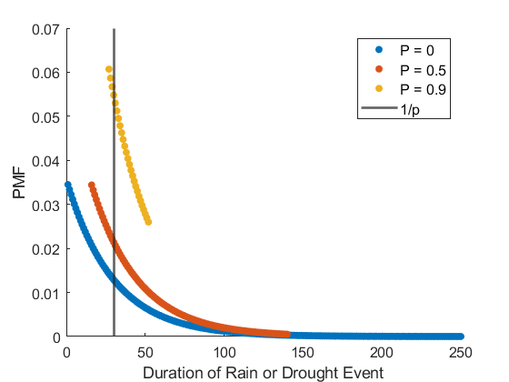**

**Figure 1**. Demonstration of how truncated geometric distributions change with P (color). Each point shows tthe probability mass functions of these distributions at different durations of rainfall or drought, and the solid black line gives the mean value for all distributions. As P increases, the ranges converge on this black line. Here, N = 250 and 1/p = 30.

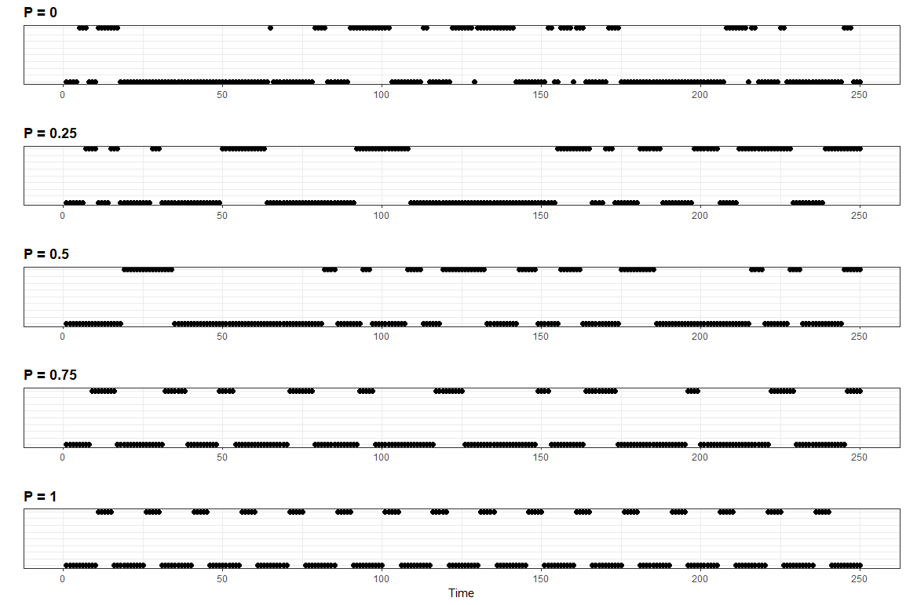

**Figure 2**. Each panel shows what state the truncated stochastic process is in (y axis, 0 or 1) every timestep (x-axis) for different values of P. As P increases, the time series becomes increasingly periodic and less stochastic.

*Description of Multi-Agent Model*

In this study, we use a model based heavily on the framework of Pepper & Smuts (2000). This type of model is an agent-based model, meaning it is composed of agents that are controlled by a simple AI that occupies a virtual, two-dimensional space. Here, agents search for food, consume it, and after they have consumed a certain amount of food they reproduce. They will also starve if their energy levels reach 0. Agents can be cooperative (they store food) or non-cooperative (they don’t store food). This is the equivalent of the feeding restraint experiments of Pepper & Smuts (2000). The offspring of an agent will take on its parent’s behavioral genotype (cooperator or non-cooperator), and resources are distributed in discrete cells (Fig. 3). A cell is a portion of land that can only contain a limited amount of food, and the amount of food can only increase when it is raining. The growth of food per cell is given by equation 4:

F_{jt} = \frac{rF_{jt-1}(K-F_{jt-1})}{K} (7)

where F is the amount of food in cell j during timestep t, r is the logistic growth rate, and K is the carrying capacity for food that the cell can contain.

Rainfall can be periodic (predictable) or random (unpredictable), or take on any intermediate value (Fig. 2). Detailed agent and cell features are given in Table 1. Simulations were run in Netlogo version 6.04 (Wilensky 1999).

| **Model Component** | **Features and Assumptions** |
| --- | --- |
| Cell | Max food per patch is K |
| Cell | Every patch starts off with a random amount of food between [0, K]. This random number is drawn from a uniform distribution with this range. |
| Cell | Amount of food present in a patch j at time i is denoted as Fjt |
| Cell | Fjt increases logistically when its raining (see equation 1), otherwise remains stagnant (Fjt = Fjt-1 when agents don't consume food) |
| Cell | Patches are square areas where the patches contain food. Patches are separated by patches that contain no food. |
| Cell | The parameter w controls the width of each patch (w = 3 gives a 3x3 patch), whereas the parameter s controls the distance between patches. Cellmin gives the minimal number of patches with food in a given simulation. |
| Agent | Each agent bears an energy value between [0,∞) |
| Agent | Agents burn a fixed amount of energy every timestep (C) |
| Agent | Agent i dies when its own energy Ei = 0. |
| Agent | Agent reproduces when Ei = 𝛉. |
| Agent | When a non-cooperative agent reproduces, it produces another non-cooperative agent. Same applies to cooperative agents. |
| Agent | When an agent reproduces, it loses a random proportion of its total energy to its offspring. |
| Agent | Non-cooperative agents consume up to EN food per timestep. If Fjt < EN, the agent will consume Fjt food. |
| Agent | We assume perfect energy transfer, agents will receive as much energy as food they consume |
| Agent | Cooperative agents consume up to EC food per timestep. If Fjt < EC, the agent will consume Fjt food. |
| Agent | EN > EC |
| Agent | Agents can move one patch per timestep |
| Agent | Agents are capable of observing all patches within a one patch radius. |
| Agent | Agents tend to avoid patches with less food than C. Otherwise they choose a random direction to move. |

**Table 1**. Descriptions of features for patches as well as agents in multi-agent simulation. We define ‘food’ as being unprocessed energy present in a patch, whereas energy is an innate trait of an agent which determines either when the agent perishes or reproduces. Most of these modeling decisions are drawn from Pepper & Smuts (2000).

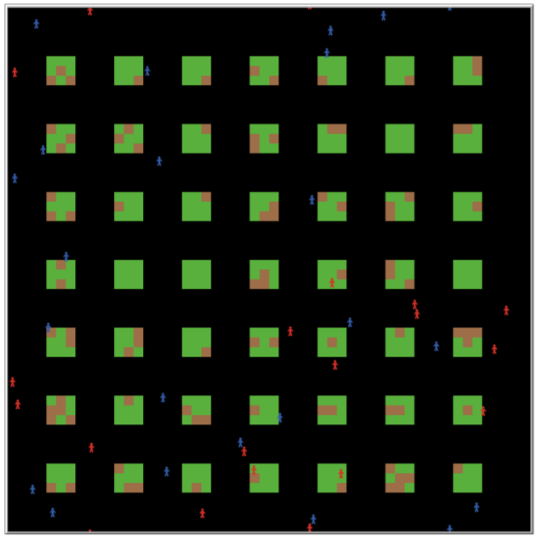

**Figure 3**. This is an example “world” within the Netlogo interface, or a representation of the space that agents inhabit in the simulations. Each island of green and brown tiles is an “patch,” blue agents are cooperators, and red agents are non-cooperators. Here, the space between patches (s) = 3, the width of the patches (w) = 3, and the minimum number of food cells (cellmin) = 500. This world was generated using the algorithm used in Pepper and Smuts (2000).

*Sensitivity Analysis*

Partial correlations give the degree of association between variables while controlling for the effects of other variables, and can thus be used as a measure of a model’s sensitivity to a particular free parameter. In these simulations, we have one response variable of interest: the ratio of surviving cooperators to the total population (RC). We also have 5 free parameters: periodicity of rainfall, average duration of rainfall, average duration of drought, width of patches, and distance between patches. We are primarily interested in the interplay between spatial and temporal scales and the stochasticity of the environment, so we only vary these parameters. All other parameters are held to the constant values found in Pepper & Smuts (2000) in order to save computational power. The logistic growth rate of food on a patch is an exception. We double the rate used in Pepper and Smuts as, on average, food is only growing half the time (during a rainfall event).

Table 2 gives the ranges and values of all constants and free parameters. Using the BehaviorSpace function in Netlogo, we ran all combinations of parameters with 10 replicates for a total of 18,000 simulations.

| **Parameter** | **Range** |
| --- | --- |
| K: Maximum Amount of Food per Cell | 10 |
| r: Logistic growth rate for patches | 0.4 |
| w: Width of patch | ∈ {2, 4, 6} |
| s: Distance between patches | ∈ {0, 2, 4, 6} |
| Cellmin | 500 |
| P: Periodicity of Rainfall | ∈ {0, .2, ..., 1} |
| 1/pR: Average duration of rainfall | ∈ {1, 3, ..., 81} |
| 1/pD: Average duration of drought | ∈ {1, 3, ..., 81} |
| C: Metabolic rate of agents | 2 |
| 𝛉: Reproductive threshold | 100 |
| EC: Proportion of food cooperators consume | 0.3 |
| EN: Proportion of food non-cooperators consume | 1 |
| Initial Population | 40 |
| Number of Timesteps Before Termination | 500 |

**Table 2**. Parameter values used in simulations.

*Statistical Analysis*

The ratio of surviving cooperators to the total population (RC) is not normally distributed (Shapiro-Wilks test p < 0.001) and is right tailed. In order to gain a deeper understanding of the effect of P on RC than what the sensitivity analysis could provide, we ran a multivariate generalized linear model (GLM) with RC as the response variable and the varied free parameters as predictor variables. As RC is right tailed and is a ratio, but doesn’t fit any tested distribution according to a chi squared goodness of fit test (p < 0.001 for all tested distributions). However, of those tested, the gamma distribution had the lowest Bayesian Information Criteria (BIC) and Akaike’s Information Criteria (AIC) values, so we used the gamma family function for the GLM with a log-link function. We ran GLMs with combinations of interactions between the predictor variables and compared their performances with AIC and BIC. The model with all possible interactions had the lowest (most negative) AIC value, and was therefore selected for analysis. As BIC discounts more complex models than AIC does, this same model only had the second lowest BIC value. However, the model with the lowest BIC value ignored interactions between predictor variables and P, so we ignored that model. P and the other free parameters of the simulation are considered fixed effects of the GLM as they can only take on the integers given in Table 2.

The final model is overdispersed, contains outliers, and the experimental distribution does not match a theoretical gamma distribution (dispersion test p < 0.001, outlier test p < 0.001, ks test p < 0.001, tests performed with DHARMa simulateResiduals function, Hartig 2019). However, this could be the result of a high sample size (n = 18,000) as residual and Q-Q plots look promising. To control for this, we bootstrapped these tests with a random sample of n = 500 from the full dataset and constructed 95% confidence intervals for both R2 of the model and the p-values for each test. R2  is reasonably high at [0.667, 0.669], the p-values for the dispersion tests are [0.069, 0.078], the p-values for the outlier tests are [0.64, 0.667], and the p-values for the ks tests are [0.162, 0.184]. Note that none of these intervals cross our significance level of 0.05, so they provide evidence of a decent model fit.

We also measured the average number of timesteps cooperators and non-cooperators survived within a simulation. As lifespan is also non-normally distributed (Shapiro-Wilks test p < 0.001), we performed a Spearman’s rank correlation test to see whether cooperator lifespan was significantly correlated with the number of surviving cooperators. We also performed this test for non-cooperators. Finally, we test whether lifespan is different between cooperators and non-cooperators within two different parameter spaces, one which promotes cooperation and one that inhibits it (Fig. 4). We make the same comparison for the proportion of time agents spend in between food patches. We test the effects of cooperation and the parameter space with Scheirer-Ray-Hare test, a nonparametric alternative to a two-way ANOVA. All statistical analyses were performed in R (R Core Team 2021) using stats, ppcor, rcompanion, fitdistrplus, EnvStats, and ggplot2 packages.

**Results**

*Sensitivity Analysis*

The sensitivity analysis reveals that when data is pooled across all simulations, the variable RC is sensitive to all parameters with the exception of P. It is negatively correlated with the width of the patches (w) and the average duration of rainfall (1/pR), meaning that when patches are large and rainfall events are short, cooperators are less likely to survive. Conversely, RC is positively correlated with the distance between patches (s) and the length of droughts (1/pD), meaning that cooperators tend to survive more often when patches are further spread apart and the droughts last for longer bouts of time. It is also worth noting that the effect size of spatial constraints (w, s) is approximately 4 times the size of temporal constraints (1/pR, 1/pD). Results are summarized in Table 3.

| **Parameter** | **Partial Correlation** | **P-Value** |
| --- | --- | --- |
| P: Periodicity of Rainfall | 0.004 | 0.0562 |
| w: Width of patch | -0.4761 | < 0.001 |
| s: Distance between patches | 0.5356 | < 0.001 |
| 1/pR: Average duration of rainfall | -0.119 | < 0.001 |
| 1/pD: Average duration of drought | 0.131 | < 0.001 |

**Table 3**. Sensitivity analysis of parameter values on the ratio of surviving cooperators to total population. All parameters have a significant effect on this ratio with the exception of P.

*Statistical Analysis*

The main effect of P on the ratio of surviving cooperators (RC) is insignificant in the final GLM (t = -0.294, p-value = 0.768). However, P has several significant interactions with other free parameters, including P:pR, P:pR:w, P:pR:w:s, and P:λR:w:s:pD (F-test p-values < 0.05). This indicates that while P may not have an effect under most circumstances, it can have an effect under specific conditions. In general, the longer rainfall/drought events are, the larger the gap between patches are, and the smaller the patches are, the stronger the effect of P on RC.

To visualize this effect, we subsetted the data such that 1/pR ≥ 27, 1/pD ≥ 27, s ≥ 5, w ≤ 2 and then performed a linear regression between P and RC. The regression is significant (p-value < 0.01) and the slope coefficient is negative (-0.084), which is consistent with the bet-hedging hypothesis. However, this effect size isn’t that high, even under these idealized conditions. Figure 4 displays the relationship between P and RC for both the full dataset and the subsetted dataset.

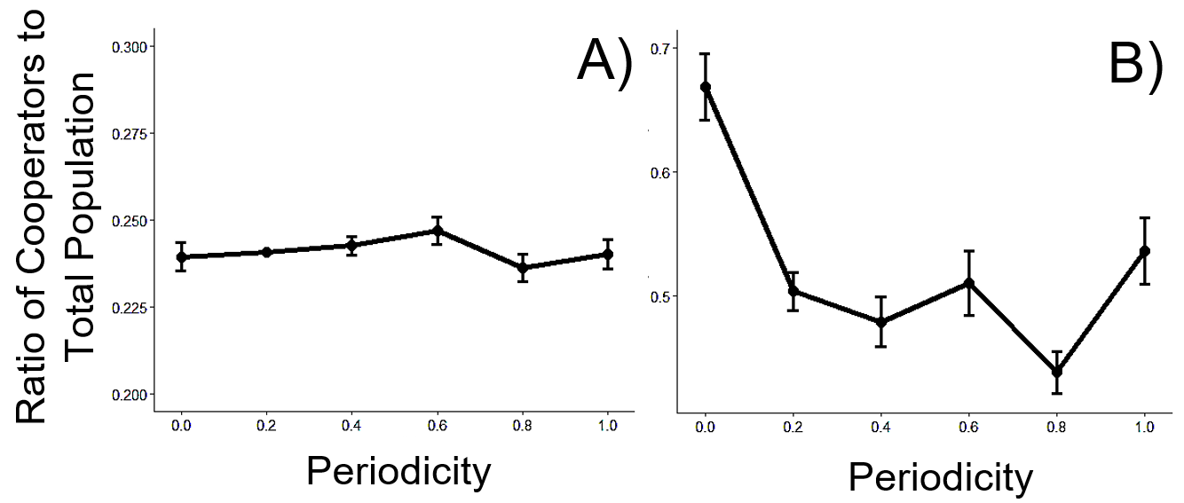

**Figure 4**. Panel A displays the relationship between periodicity and the ratio of surviving cooperators in the full dataset, whereas panel B does the same for the subsetted dataset where 1/pR ≥ 27, 1/pD ≥ 27, s ≥ 5, w ≤ 2. Error bars represent standard error. Note that the scales of the y-axes on both diagrams are different, as error bars for Panel A are not visible at the scale necessary to see the data range for Panel B.

This effect could, in part, be the result of non-cooperators dying in transit to other patches. Predictably, the average lifespan of both cooperators and non-cooperators are significantly correlated with the average number of cooperators and non-cooperators, respectively (Spearman’s correlation test for cooperators: rho = 0.14, p < 0.001, non-cooperators: rho = 0.667, p < 0.001). The lifespans of cooperators and non-cooperators are also different (Scheirer-Ray-Hare H = 9192.7, p < 0.001), as well as the agents inside or outside of the parameter space 1/pR ≥ 27, 1/pD ≥ 27, s ≥ 5, and w ≤ 2 (Scheirer-Ray-Hare H = 524.1, p < 0.001). These two factors also significantly interact (Scheirer-Ray-Hare H = 197.4, p < 0.001), indicating that all combinations of factors are significantly different from one another (Fig. 5A). While the average lifespans of non-cooperators are significantly higher than those of cooperators overall, their lifespans diminish in the cooperation promoting parameter space (Fig. 5A). Non-cooperators also spend significantly more time in the space between patches than non cooperators do (Fig. 5B), an effect which is amplified in the cooperation promoting parameter space (Scheirer-Ray-Hare cooperator vs noncooperator: H = 996.63, p < 0.001; parameter space: H = 254.52, p < 0.001; interaction: H = 3.75, P = 0.0527).

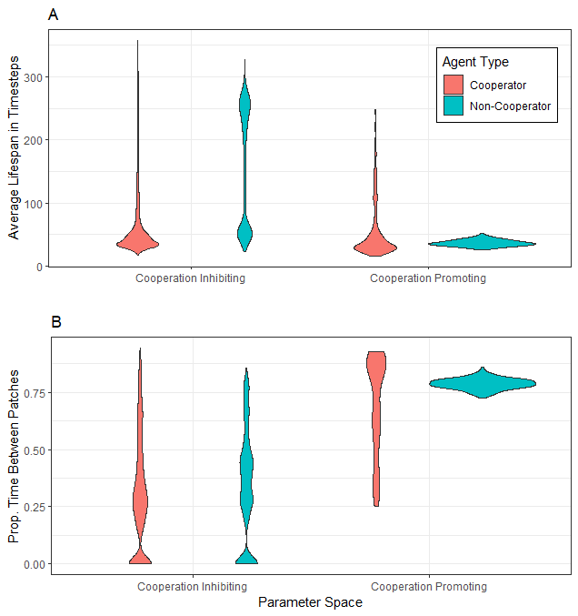

**Figure 5**. Violin plot showing distributions of A) lifespans of cooperators and non-cooperators in two different parameter spaces (color) and B) average proportion of time spent on the space between patches. The cooperation promoting space is the space where 1/pR ≥ 27, 1/pD ≥ 27, s ≥ 5, and w ≤ 2 whereas the cooperation inhibiting region covers the rest of the parameter space.

**Discussion**

The randomness of rainfall alone cannot explain the prevalence of cooperative behavior on Rapa Nui. When resources are spread homogeneously, non-cooperators outcompete cooperators, which is consistent with the original Pepper and Smuts model (2000). However, when resources become increasingly dispersed, rainfall events are separated by longer stretches of time, and rainfall is random, then cooperators start to dominate more frequently. In the context of this model, this likely occurs because non-cooperators consume all the resources on their patch prematurely and may choose to leave a resource patch after only short rainfall events (which are more likely to occur when rainfall is random). They then die in transit to distant patches. Bet-hedging cooperators in this scenario are more likely to survive on a patch long enough for the next rain to come.

This dependence on heterogeneity seems largely concordant with dispersion models of the island (Hunt & Lipo 2018). These models contend that dispersing communities across the island confers several advantages. For instance, dispersed communities are more robust to resource shortfalls than centralized communities (food sharing across communities can buffer against risk creating variable decision outcomes; Cashdan 1992). Dispersion also protects against drift, and thus maintains cultural diversity (Lipo et al. 2021). *Moai* construction in these dispersed communities could have also decreased the threat of conflict over unevenly distributed resources (costly signaling), and enforced information sharing through communal activities (Gintis et al. 2001).

The geography of the island may have influenced the dispersion of island communities. If one interprets the ‘world’ that the agents inhabit as the island of Rapa Nui (a justifiable assumption given the islanders were unable to build long range vessels after the Easter Island palms disappeared, Arana 2014), then a patch could be interpreted as a fertile piece of land, perhaps hydrated by a freshwater spring (DiNapoli et al. 2021). Freshwater springs on the island are likely spread heterogeneously along the coast (Diapoli et al. 2019). These springs could have acted as nucleation sites for communities, as *ahu* could have been built close to these springs (DiNapoli et al. 2019). This feature of the island, when coupled with the randomness of its rainfall (supplementary material), could have provided evolutionary pressure needed for the islanders to be cooperative and build the foundation of a long-lived society. This could also help explain how civilization managed to persist on Rapa Nui but not on Rapa Iti, where resources are spatially dense and temporally predictable (DiNapoli et al. 2018). At larger scales these patches could also represent islands in the pacific (Alkire, 1984), and this simulation could represent the migratory period before Rapa Nui was settled. The evolutionary pressure for cooperation, then, could have been present both before and after colonization.

Additionally, the distribution of interarrival times between rainfall events on the island is right tailed (Fig. S1), indicating that there are occasionally long periods of drought. According to our model, this could provide further pressure for cooperation. We also observe no long term trends in rainfall on the island over the past 40 years (supplemental material), so there may have been minimal cross-generational environmental variation, which in turn could help cooperative traditions persist through the centuries (Giluliano & Nunn 2021). Matching the scale of a human lifetime to the timescale of rainfall could be critical in understanding how the islanders survived the island.

The implications of this study may extend to fields outside of anthropology, including astrobiology, evolutionary biology, and animal behavior. Specifically, it may provide insights into the evolution of eusociality of social insects. Eusociality, perhaps the most extreme form of cooperation in nature, occurs when members of a group (called a colony or hive for social insects) sacrifice their own ability to reproduce for the collective wellbeing of the group (Wilson & Hölldobler 2005). Most social insects, classified within the clade Hymenoptera, evolved from a solitary wasp species (Peters et al. 2017). It is difficult to trace the origins of eusociality, as traditional arguments over the benefits of economies of scale fail (namely specialized workers are not more efficient, Dornhaus et al. 2009), kin selection has limited applicability to the evolution of eusociality (Nowak et al. 2010, but see Xiaoyun et al. 2015), and strong division of labor (a defining characteristic of eusociality) among founding ant queens leads to increased mortality rates (Cahan & Fewell 2004). Bees have been shown to bet-hedge while foraging (Burns & Dyer 2008), so it may be possible that bet-hedging among reproductive insects in an unpredictable environment may have set the stage for eusociality. Approaches taken in this study may be directly applicable to that field, as social insect scientists use the same kind of modeling technique that we employ (agent-based modeling; Drogoul & Ferber 1992).

**Works Cited**

ALKIRE, W. H. (1984). Central Carolinian oral narratives: Indigenous migration theories and principles of order and rank. *Pacific Studies*, *7*, 14-14.

ARANA, P. M. (2014). Ancient fishing activities developed in Easter Island. *Latin American Journal of Aquatic Research*, *42*(4), 673-689.

BURNS, J. G., & Dyer, A. G. (2008). Diversity of speed-accuracy strategies benefits social insects. *Current biology*, *18*(20), R953-R954.

CAHAN, S. H., & Fewell, J. H. (2004). Division of labor and the evolution of task sharing in queen associations of the harvester ant Pogonomyrmex californicus. *Behavioral ecology and sociobiology*, *56*(1), 9-17.

CASHDAN E. A. (1992). Spatial organization and habitat use. In Smith, E. A., and Winterhalder, B. (eds.), Ecology, Evolution, and Human Behavior, Aldine de Gruyter, Hawthorne, NY, 237–268.

COE, R., & Stern, R. D. (1982). Fitting models to daily rainfall data. *Journal of Applied Meteorology and Climatology*, *21*(7), 1024-1031.

COHEN, J. (1992). A power primer. *Psychological bulletin*, *112*(1), 155.

DORNHAUS, A., Holley, J. A., & Franks, N. R. (2009). Larger colonies do not have more specialized workers in the ant Temnothorax albipennis. *Behavioral Ecology*, *20*(5), 922-929.

DINAPOLI, Robert J., et al. "East Polynesian islands as models of cultural divergence: the case of Rapa Nui and Rapa Iti." *The Journal of Island and Coastal Archaeology* 13.2 (2018): 206-223.

DINAPOLI, R. J., Lipo, C. P., Brosnan, T., Hunt, T. L., Hixon, S., Morrison, A. E., & Becker, M. (2019). Rapa Nui (Easter Island) monument (*ahu*) locations explained by freshwater sources. *PloS one*, *14*(1), e0210409.

DINAPOLI, R. J., Lipo, C. P., de Smet, T. S., & Hunt, T. L. (2021). Thermal Imaging Shows Submarine Groundwater Discharge Plumes Associated with Ancient Settlements on Rapa Nui (Easter Island, Chile). *Remote Sensing*, *13*(13), 2531.

DINAPOLI, R. J., Lipo, C. P., & Hunt, T. L. (2021). Triumph of the Commons: Sustainable Community Practices on Rapa Nui (Easter Island). *Sustainability*, *13*(21), 12118.

DROGOUL, A., & Ferber, J. (1992). Multi-agent simulation as a tool for modeling societies: Application to social differentiation in ant colonies. In *European workshop on modelling autonomous agents in a multi-agent world* (pp. 2-23). Springer, Berlin, Heidelberg.

GINTIS, H., Smith, E. A., & Bowles, S. (2001). Costly signaling and cooperation. *Journal of theoretical biology*, *213*(1), 103-119.

GIULIANO, P., Nunn, N. (2021). Understanding cultural persistence and change. The Review of Economic Studies, 88(4), 1541-1581.

HARTIG, F. (2019). DHARMa: residual diagnostics for hierarchical (multi-level/mixed) regression models. *R package version 0.2*, *4*.

HUNT, T. L., & Lipo, C. P. (2009). Revisiting Rapa Nui (Easter Island) “Ecocide” 1. *Pacific Science*, *63*(4), 601-616.

HUNT, T., & Lipo, C. (2012). Ecological Catastrophe and Collapse: The Myth of 'Ecocide' on Rapa Nui (Easter Island). *PERC Research Paper*, (12/3).

HUNT, T. L., & Lipo, C. (2018). The Archaeology of Rapa Nui (Easter Island). *The Oxford Handbook of Prehistoric Oceania. Oxford University Press, New York*, 416-449.

KENNEDY, P., Higginson, A. D., Radford, A. N., & Sumner, S. (2018). Altruism in a volatile world. *Nature*, *555*(7696), 359-362.

LADEFOGED, T. N., Flaws, A., & Stevenson, C. M. (2013). The distribution of rock gardens on Rapa Nui (Easter Island) as determined from satellite imagery. *Journal of Archaeological Science*, *40*(2), 1203-1212.

LANE, B. G. (2017). Geospatial modelling for predicting the ideal free settlement of Rapa. *Archaeology in Oceania*, 52(1), 13-21.

LA PÉROUSE J. F. G. (1798). A Voyage Round the World Performed in the Years 1785, 1786, and 1788. *London: J. Johnson*.

LIPO, C. P., DiNapoli, R. J., Madsen, M. E., & Hunt, T. L. (2021). Population structure drives cultural diversity in finite populations: A hypothesis for localized community patterns on Rapa Nui (Easter Island, Chile). *PloS one*, *16*(5), e0250690.

LIPO, C. P., Hunt, T. L., & Haoa, S. R. (2013). The ‘walking’ megalithic statues (*moai*) of Easter Island. *Journal of Archaeological Science*, *40*(6), 2859-2866.

MORRISON, A. E. (2012). *An archaeological analysis of Rapa Nui settlement structure: a multi-scalar approach* (Doctoral dissertation, University of Hawai'i at Manoa).

MULLOY, W.T. Contemplate the Navel of the World. *Americas* 1974, 26, 25–33.

MULROONEY, M. A., Ladefoged, T. N., Stevenson, C. M., & Haoa, S. (2010). Empirical assessment of a pre-European societal collapse on Rapa Nui (Easter Island). In *The Gotland papers: Selected papers from the VII international conference on Easter Island and the Pacific: Migration, identity, and cultural heritage* (pp. 141-154). Gotland University Press Gotland.

MULROONEY, M. A. (2013). An island-wide assessment of the chronology of settlement and land use on Rapa Nui (Easter Island) based on radiocarbon data. *Journal of Archaeological Science*, *40*(12), 4377-4399.

NOWAK, M. A., Tarnita, C. E., & Wilson, E. O. (2010). The evolution of eusociality. *Nature*, *466*(7310), 1057-1062.

OLOFSSON, H., Ripa, J., & Jonzén, N. (2009). Bet-hedging as an evolutionary game: the trade-off between egg size and number. *Proceedings of the Royal Society B: Biological Sciences*, *276*(1669), 2963-2969.

PEPPER, J. W., & Smuts, B. B. (2000). The evolution of cooperation in an ecological context: an agent-based model. *Dynamics in Human and Primate Societies: Agent-Based Modeling of Social and Spatial Processes*, 45-76.

PETERS, R. S., Krogmann, L., Mayer, C., Donath, A., Gunkel, S., Meusemann, K., ... & Niehuis, O. (2017). Evolutionary history of the Hymenoptera. *Current Biology*, *27*(7), 1013-1018.

PHILIPPI, T., & Seger, J. (1989). Hedging one's evolutionary bets, revisited. *Trends in ecology & evolution*, *4*(2), 41-44.

R Core Team (2021). R: A language and environment for statistical computing. R Foundation for Statistical Computing, Vienna, Austria. URL [http://www.R-project.org/](https://www.r-project.org/)

RATCLIFF, W. C., & Denison, R. F. (2010). Individual-level bet hedging in the bacterium Sinorhizobium meliloti. *Current Biology*, *20*(19), 1740-1744.

UITDEHAAG, J. C. (2011). Bet hedging based cooperation can limit kin selection and form a basis for mutualism. *Journal of theoretical biology*, *280*(1), 76-87.

WILKINSON, G. S. (1990). Food sharing in vampire bats. *Scientific American*, *262*(2), 76-83.

WILSON, E. O., & Hölldobler, B. (2005). Eusociality: origin and consequences. *Proceedings of the National Academy of Sciences*, *102*(38), 13367-13371.

ZHANG, X. X., & Rainey, P. B. (2010). Bet hedging in the underworld. *Genome biology*, *11*(10), 1-3.

**Supplementary material**

*Measuring Periodicity on Rapa Nui*

To validate the multi-agent model, it is necessary that we get a rough estimate of the predictability of rainfall on Rapa Nui. If rainfall is highly predictable on the island, then that might favor the emergence of non-cooperators. Conversely, if it's highly unpredictable, then cooperators might be selected instead. Predictability can be measured in a number of ways. Here, we test whether rainfall is periodic (that is, sequential rainfall and drought events are approximately the same length) and whether or not the seasonal cycles of rainfall are powerful enough to be detected by a pre-industrial society.

Daily rainfall measurements (measured in inches) were taken from an airport gauge at Mataveri. While the dataset is extensive - measurements date back to 1966 - it is also incomplete. Entire months worth of data are absent for some years. This missing data does not affect the periodicity test as that analysis measures distributions pooled across years. However, these missing values can potentially bias the time-series analysis as some years and months will have a larger sample size than others. To control for this bias, we only analyze years which have at least 10 days present in all 12 months (1982 - 2021). We then randomly sample without replacement 10 days within each month to get the average amount of rainfall in inches for that month.

To test for periodicity, we first encode each day as either having rain (inches of rainfall > 0) or having no rain (inches of rainfall = 0). We then measure the run-lengths of all rainfall events (the number of consecutive days with rain) and drought events (the number of consecutive days without rain, see Fig. S1). The distinguishing feature of a periodic environment is that these distributions are truncated at both ends, so we compare the fits of exponential distributions to truncated exponential distributions to the rainfall and drought distributions. We fit both exponential and truncated exponential distributions (where P is a free parameter, see equations 1-3) using maximum likelihood estimations. We then compare the fits with a two-sample Kolmogorov–Smirnov test as well as AIC/BIC.

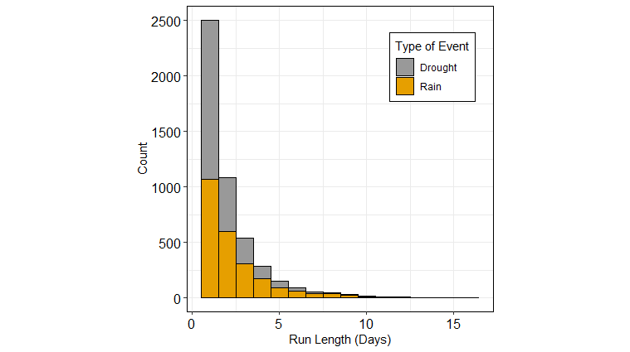

**Figure S1**. Histogram of the run lengths for both rain (gold) and drought (gray) on Rapa Nui. Run lengths give the number of consecutive days with either 0 inches of rain (drought) or more than 0 inches (rain).

While the two fits are different from one another for both rainfall and drought events (Rain; D = 0.2, P < 0.05, Drought; D = 0.27, P < 0.01), the truncated distribution seems to add unnecessary complexity to the model (Table S1). The data, therefore, seems aperiodic, as an exponential distribution (which has a periodicity of 0) outperforms all periodic distributions (0 < periodicity ≤ 1).

|  | Exponential AIC | Truncated AIC | Δ AIC | Exponential BIC | Truncated BIC | Δ BIC |
| --- | --- | --- | --- | --- | --- | --- |
| Rain Events | -9.1865 | -8.3012 | -0.8853 | -9.1807 | -8.2838 | -0.8969 |
| Drought Events | -8.446 | -6.7647 | -1.6813 | -8.44 | -6.7468 | -1.6932 |

Table S1: AIC/BIC compare exponential and truncated distributions for both rainfall events as well as drought events. The exponential distribution has both a lower AIC and BIC value for both rainfall and drought.

While the presence of rain might not be periodic, the amount of rainfall might predictably vary with the season (Hunt & Lipo 2011; Morrison 2012). This pattern roughly corresponds to the wet season between April and June and the dry season between October and January. While the effect is significant, the effect size may not be meaningful, as ancient islanders may not have been able to measure small effect sizes. We therefore use the Holt-Winters method to decompose the time series and compute the signal to noise ratio. The higher this ratio, the more predictable the rainfall.

First, we perform a linear regression between time and the average amount of rain on a monthly basis to determine whether there is a linear trend (Fig S2A). This regression, however, is insignificant (t = -1.267, p = 0.2057). The decomposed trend from the Holt-Winters forecast also appears flat overall (Fig. S2B). This gives us a small indication that rainfall patterns may not have changed since Rapa Nui was first settled. We can also see that Rapa Nui experiences yearly fluctuations in rainfall (Fig. S2C) however this seasonal fluctuation is much smaller in scale than random noise (Fig. S2D). Indeed, the signal-to-noise ratio (root mean squares of seasonality / root mean squares of noise) of the seasonal effect is a paltry 0.175 (the standard limit of detection is 3 for a time series, Sheenan & Yost 2015). This, combined with the flat trend, results in a forecasting model that does not fit the data well (R2 = 0.0862). It also does not predict future events well. When we fit the model on half of all available years (selected randomly) and use that model to predict the rainfall of the other half, the resulting R2 is 0.0201.

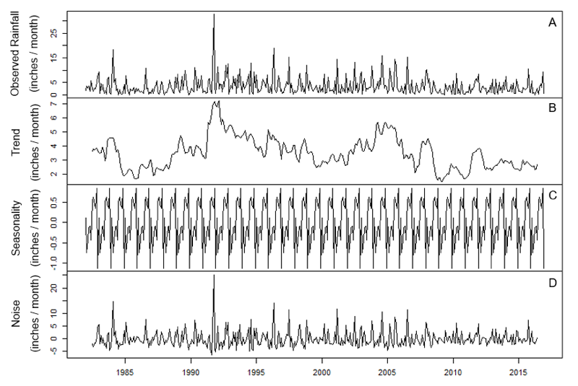

**Figure S2**. Decomposition of rainfall time-series with Holt-Winters method. A) Observed average rainfall per month from 1982 to 2021. B) Overall trend in average rainfall per month. C) Yearly seasonality of average rainfall per month. D) Independent randomness (noise) of rainfall. Panel A is the sum of panels B-D.

We also measured predictability by calculating the autocorrelation of rainfall between months. A Box-Ljung test indicates that at least one autocorrelation between lags 1 and 20 is significantly different from 0 (X-squared = 36.213. p < 0.05), and when we plot these autocorrelations the only significant lag is 1 (Fig. S3). This means that the rainfall of one month depends significantly on rainfall from the previous month. However, the correlation of 0.186 is small according to Cohen’s thresholds for effect sizes (1992). 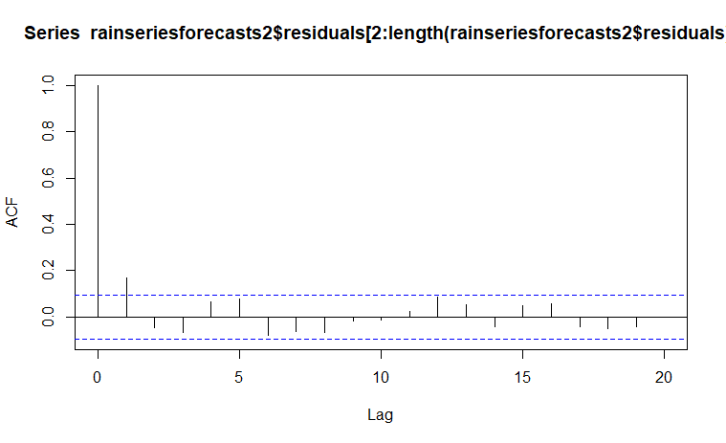

**Figure S3**. Autocorrelation function (ACF) for average rainfall per month on Rapa Nui. ACF measures how strongly the rainfall of a focal month correlates with previous months. Lag determines how many months back we measure. Lag = 0 measures the correlation between a month of rain and itself (which is 1). Lag = 1 measures correlation between a focal month and the month previous, and so on. Blue lines indicate 95% confidence intervals. The only nonzero lag to cross this threshold is lag = 1.

Generally, we find that rainfall on Rapa Nui is aperiodic, and while there is evidence of yearly fluctuations in rainfall, it is unclear just how useful this information would be for the people of Rapa Nui. The effect sizes for each analysis are small, so any cyclic signal may only be detectable with careful and frequent measurements, which may have been beyond the technological capabilities of the islanders. If they did not keep accurate records of rainfall, then rainfall may have appeared unpredictable to them.

*Bias in rainfall data*

Due to malfunctions in equipment, changes in technology over time, worker availability, and other factors, rainfall data on Rapa Nui has not been collected consistently on either a yearly (Fig. S4A) or monthly (Fig. S4B) basis. Bias can therefore be introduced to estimations of cyclic patterns in rainfall by inadvertently sampling in some months more often than others, and therefore our measurement of the signal-to-noise ratio of seasonality could be misleading. To test for the presence of bias, we first sampled from the raw dataset using the sampling technique in the previous section. From this bootstrapped sample we decomposed the seasonal effect from the Holt-Winters forecast to get the difference from the average rainfall in a month from the average rainfall overall. We sampled 500 times, allowing us to construct 99% confidence intervals of the seasonal effects for each month (Fig. S5). Next, we build a forecast model using the raw data alone to see if the aggregate seasonal effect falls within these confidence intervals.

The seasonal effect from the raw data does not overlap confidence intervals for all 12 months, although the two are correlated with one another (Spearman’s correlation, df = 10, rho = 0.874, p-value < 0.001). In fact, the amount of deviance between the bootstrapped seasonal effect for a month and the raw data estimate for the seasonal effect for that month ( |bootstrap sample mean - aggregate mean|, Fig S6) is nearly inversely correlated with the number of times that month was sampled (Fig. S5A, Spearman’s correlation, df = 10, rho = -0.443, p = 0.112), indicating that biases in the seasonal effect might be caused by unequal sampling.

Still, even when we control for this bias, the seasonal effect is still extremely small. The maximum seasonal effect from the bootstrap samples is about 3 (Fig. S6), and therefore the best case scenario for the signal to noise ratio is about 0.83. This is still well below the standard threshold of 3, so it is still the case that the Rapa Nui people were unlikely to effectively measure seasonality in rainfall.

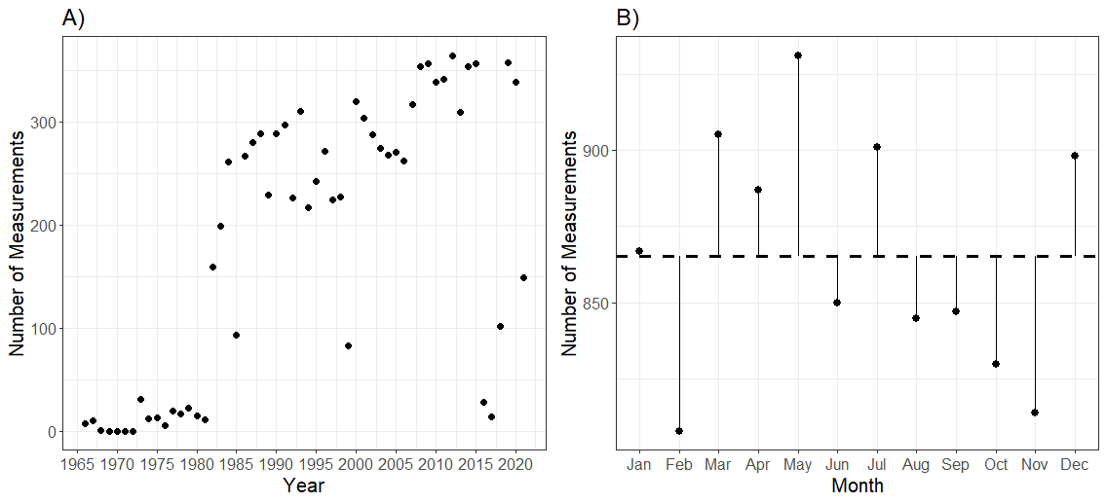

**Figure S5**. Total number of rainfall measurements across years (A) and months (B). In (B), the dashed line represents a uniform distribution of measurements across each month, and the solid black line represents the difference between the real measurement and the expected value of the uniform distribution.

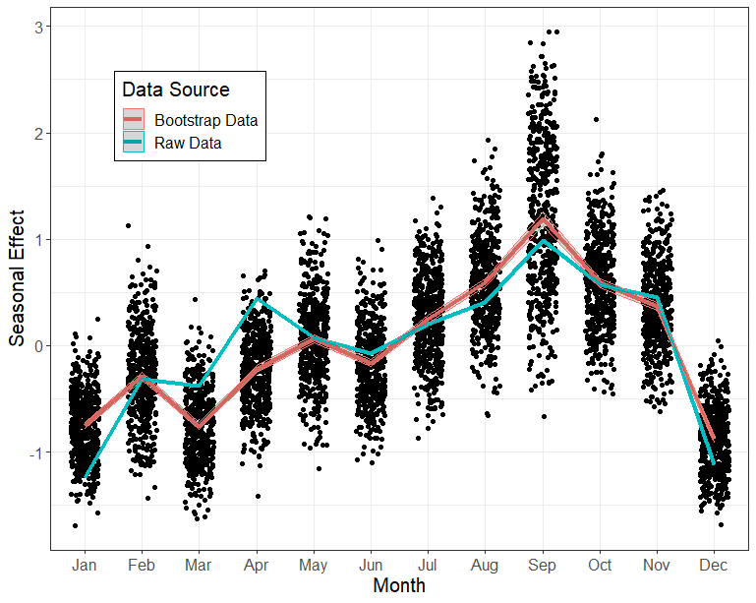

**Figure S6**. Bootstrap sampling seasonal effect vs the seasonal effect of the raw data. Each point represents the seasonal effect of that particular month for a bootstrapped sample, using the sampling rules from the previous section. The red line shows the average value of each month, and the shaded region represents the 99% confidence interval. The blue line shows the seasonal effect from the full, unsampled dataset.

*Showing truncated geometric distribution is a PMF*

In its full form, the PMF of a truncated geometric distribution is given by:

P(X = x) = \left\{
        \begin{array}{ll}
            \frac{p(1-p)^{x-1}}{(1-p)^a - (1-p)^b} & \quad  a \leq x \leq b \\
            0 & \quad \text{otherwise}
        \end{array}
    \right. (8)

To be a valid PMF, the sum of this distribution between a and b needs to be 1:

\sum_{x=a}^b \frac{p(1-p)^{x-1}}{(1-p)^a-(1-p)^b}\\=
\frac{p}{(1-p)^a-(1-p)^b} \sum_{x=a}^b(1-p)^{x-1}\\
=\frac{p(1-p)^a}{(1-p)^a-(1-p)^b} \sum_{x=0}^{b-a}(1-p)^{x-1}\\
=\frac{p(1-p)^a}{(1-p)^a-(1-p)^b}\frac{(1-p)^{b-a-1+1}-1}{(1-p)-1}\\
=\frac{(1-p)^{b-a}-1}{(1-p)^{b-a}-1} = 1